**Commodore PET IEEE-488 Extender Base Board Rev. 0**

**Module Description**

The IEEE-488 extender can serve multiple purposes:

1. Splitting the card edge IEEE-488 connector, so an additional device other than a SD2PET future can be connected.
2. Connecting a cheap DIY ribbon IEEE-488 cable. It is recommended to keep this ribbon cable as short as possible

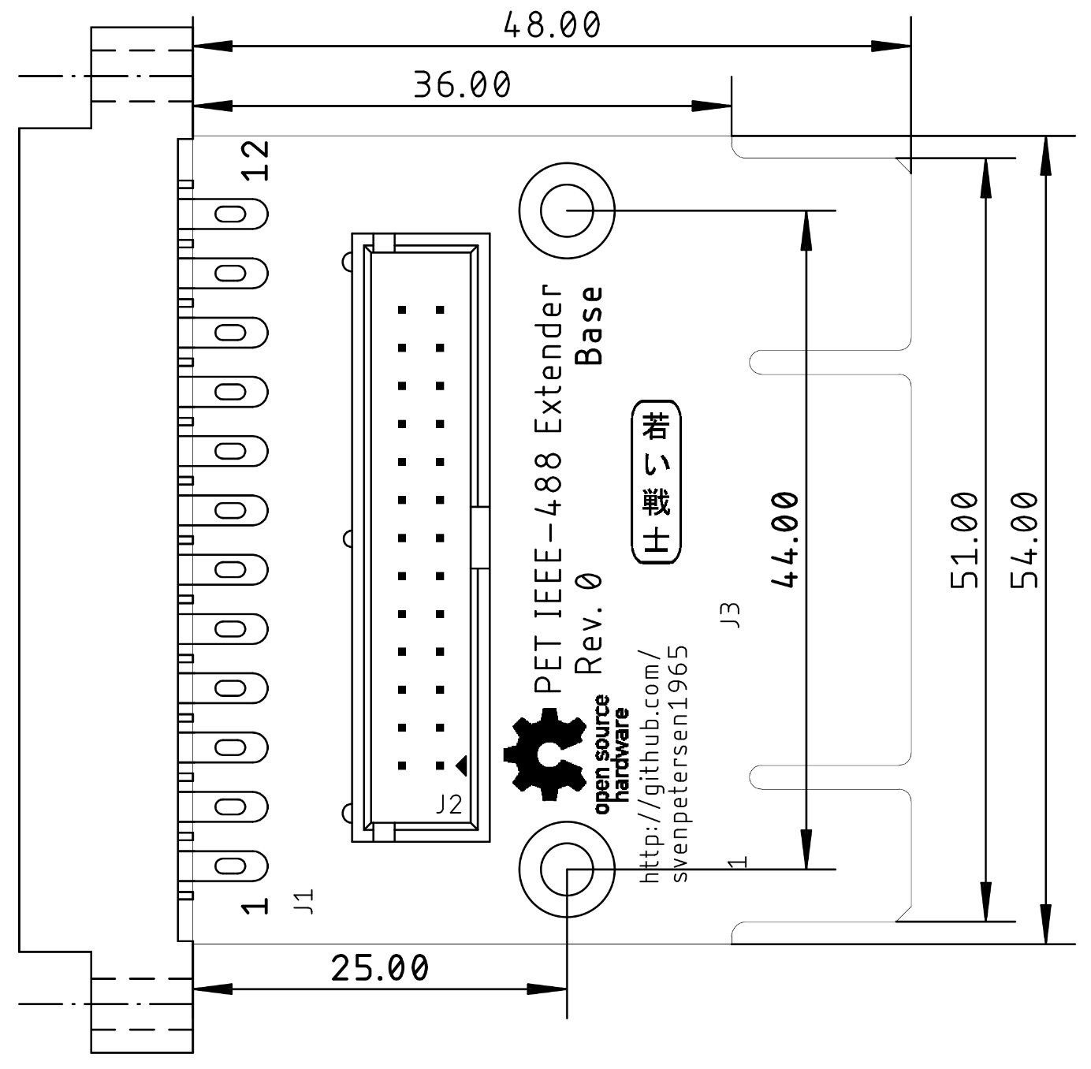

Figure 1: Dimensions of the IEEE-488 Extender

# Connectors

**J1** is a female card edge connector, that connects to the PET/CBM Mainboard, **J3** is a card edge structure on the PCB, which connects to the IEEE-488 peripherals via the PET-IEEE-488 cable or directly (in case of the SD2PET future). J2 is a 2x13 pin header/box connector.

|  |  |  |  |  |  |
| --- | --- | --- | --- | --- | --- |
| J1, J3/top | Signal | J2 | J2 | Signal | J1, J3/bottom |
| 1 | DIO1 | 1 | 2 | DIO5 | A |
| 2 | DIO2 | 3 | 4 | DIO6 | B |
| 3 | DIO3 | 5 | 6 | DIO7 | C |
| 4 | DIO4 | 7 | 8 | DIO8 | D |
| 5 | EOI | 9 | 10 | REN | E |
| 6 | DAV | 11 | 12 | GND | F |
| 7 | NRFD | 13 | 14 | GND | H |
| 8 | NDAC | 15 | 16 | GND | J |
| 9 | IFC | 17 | 18 | GND | K |
| 10 | SRQ | 19 | 20 | GND | L |
| 11 | ATN | 21 | 22 | GND | M |
| 12 | GND | 23 | 24 | GND | N |
| - | GND | 25 | 26 | GND | - |

Table 1: IEEE-488 signal pinouts

# Pictures

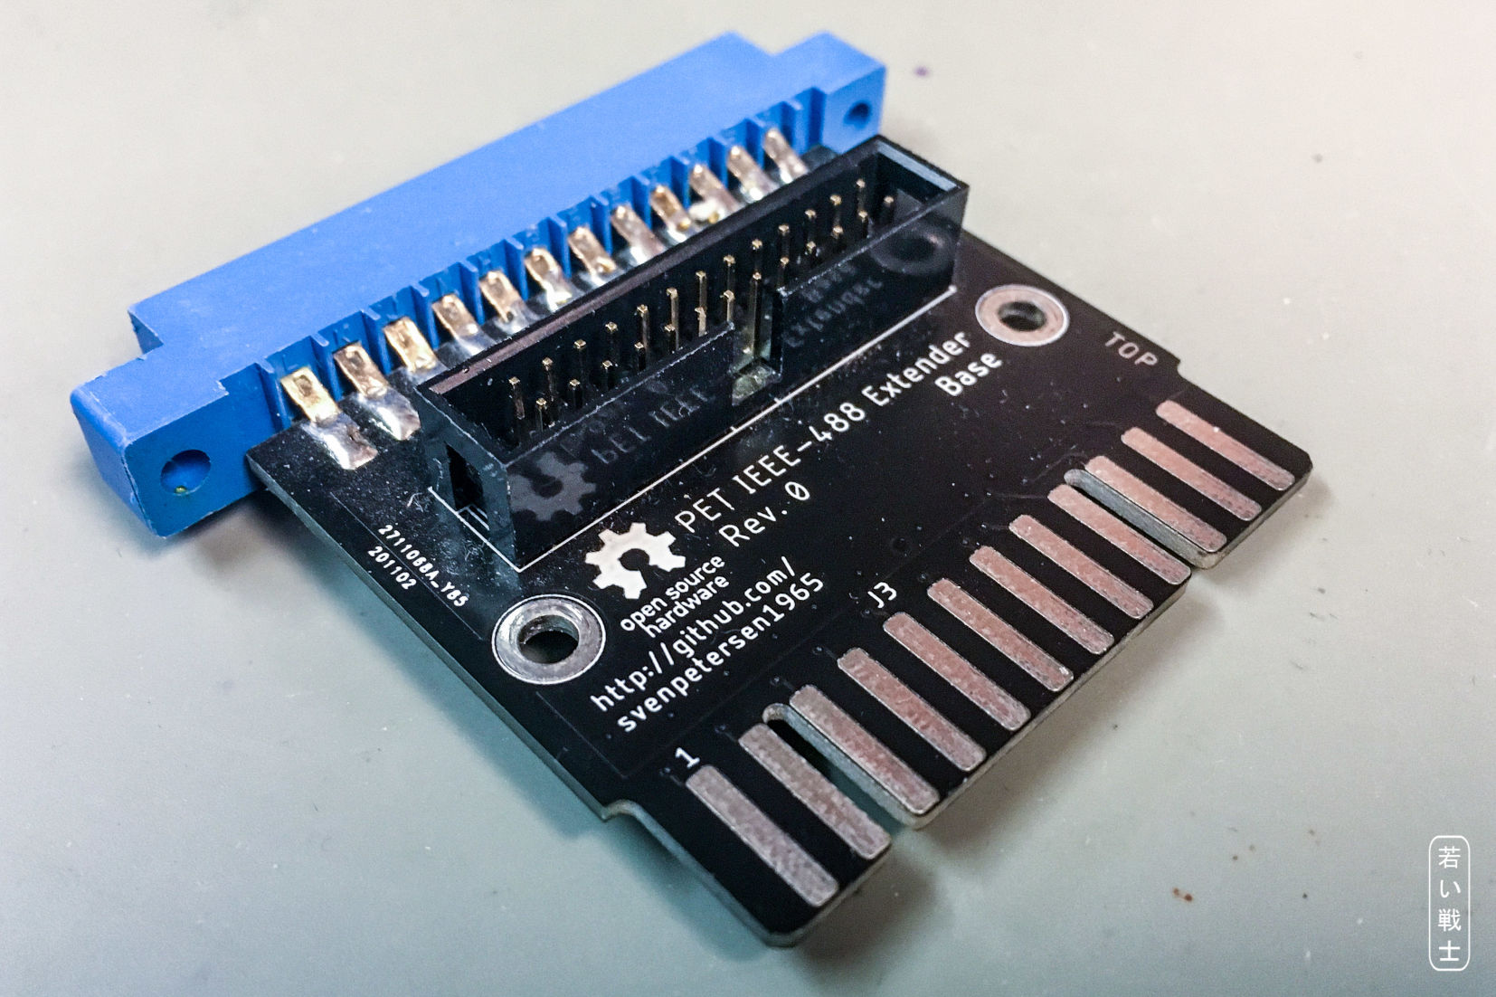

Figure 2: IEEE-488 Extender Base Board

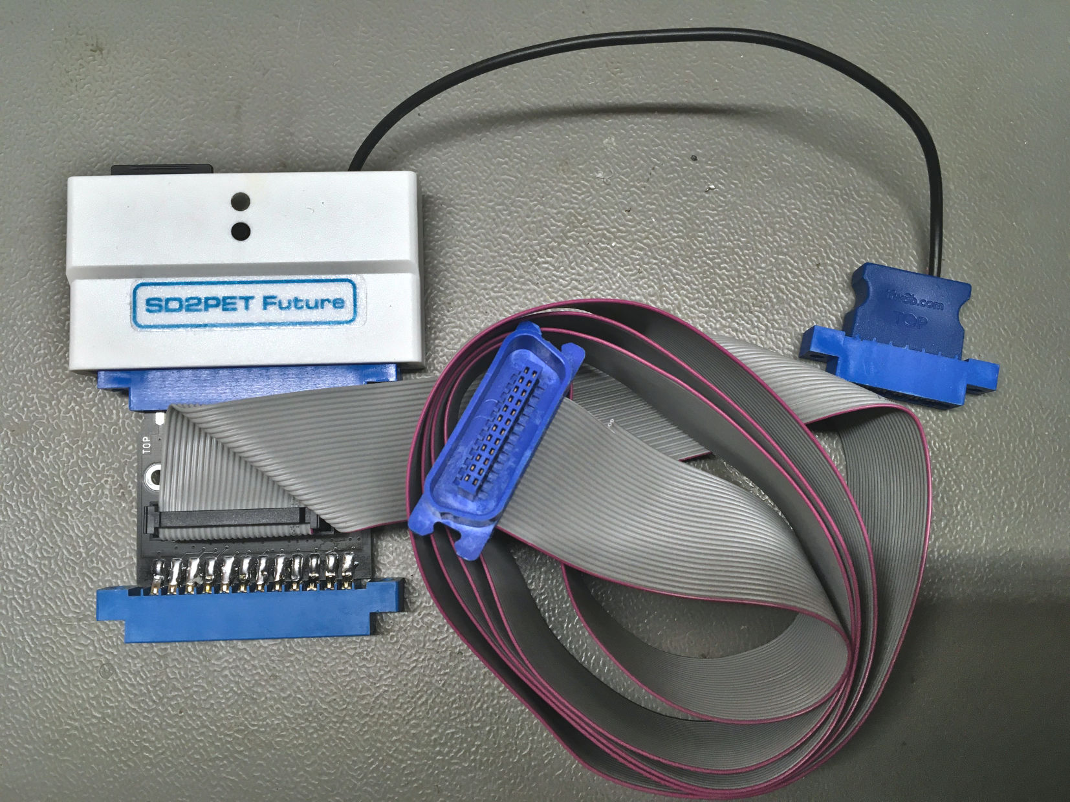

Figure 3: Base Board with SD2PET Future and a ribbon cable

# Revision History

## Rev. 0

* Prototype (fully functional)